JOMO KENYATTA UNIVERSITY OF AGRICULTURE AND TECHNOLOGY
BACHELOR OF SCIENCE IN INFORMATION TECHNOLOGY
BIT 2319 ARTIFICIAL INTELLIGENCE
LAB TUTORIAL I

  - Explain the following terms and give examples of each
    - Algorithm
    - Data structure
    - Recursive algorithm
    - Analysis of algorithm
  - Distinguish between data abstraction and data structures with the aid of appropriate examples

    - Discuss the motivation behind the use of recursion in programming
    - Consider the following recursive definition:
n+1 if m=0
Acker (m, n) = Acker (m-1, 1) if n=0
Acker (m-1, Acker (m, n-1)) otherwise

This function, called Ackermann’s function, is of interest because it grows rapidly with respect to the sizes of m and n.
      - What is Acker (1, 2)? Show your working
      - Write a program in C/C++/Java to implement the function and test Acker(1,2). Compare the output with (I) above

  - Draw a binary Tree for the expression : A * B - (C + D) * (P / Q)
  - Traverse the tree in
    - Inorder
    - Preorder and
    - Postorder traversals
  - Consider the following digraph G where the alphabetic order of node names defines the ordering of neighbors of each node.

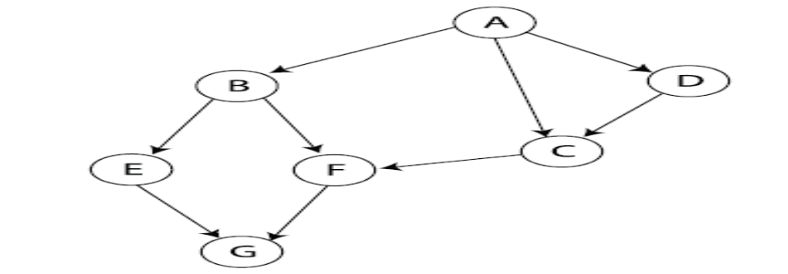
  - Show the order of visiting its nodes during the breadth-first search starting at A and using the neighbor ordering mentioned above.
  - Show the order of visiting its nodes during the depth-first search starting at A and using the same neighbor ordering. Draw the resulting depth-first search tree.

- Look up the ALICE chatting robot (or ELIZA the therapist) on the internet and chat with 'her'. In your opinion is she intelligent. How was is the knowledge stored? How is inferencing done?
- Search on the internet on MYCIN, a knowledge-based system and read on it. How is knowledge stored? How does the inference engine work?
- Search on the internet on the Turing Test and the Chinese room experiment, and describe them.
  - If the Turing Test is passed, does this show that computers exhibit intelligence? State your reasons using appropriate examples
  - If the chinese room experiment is passed, does this show that computers exhibit intelligence. State your reasons using appropriate examples

